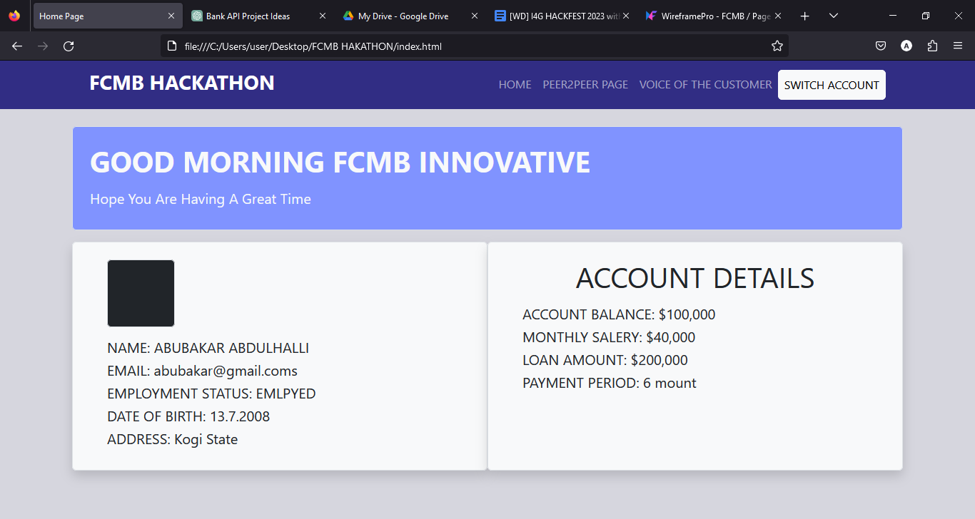

Customer personal detail

Customer account detail section

Home page

Peer2peer section

Voice of the customer section

THIS SECTION IS TO SWITCH BETWEEN DIFFERENT ACCOUNT

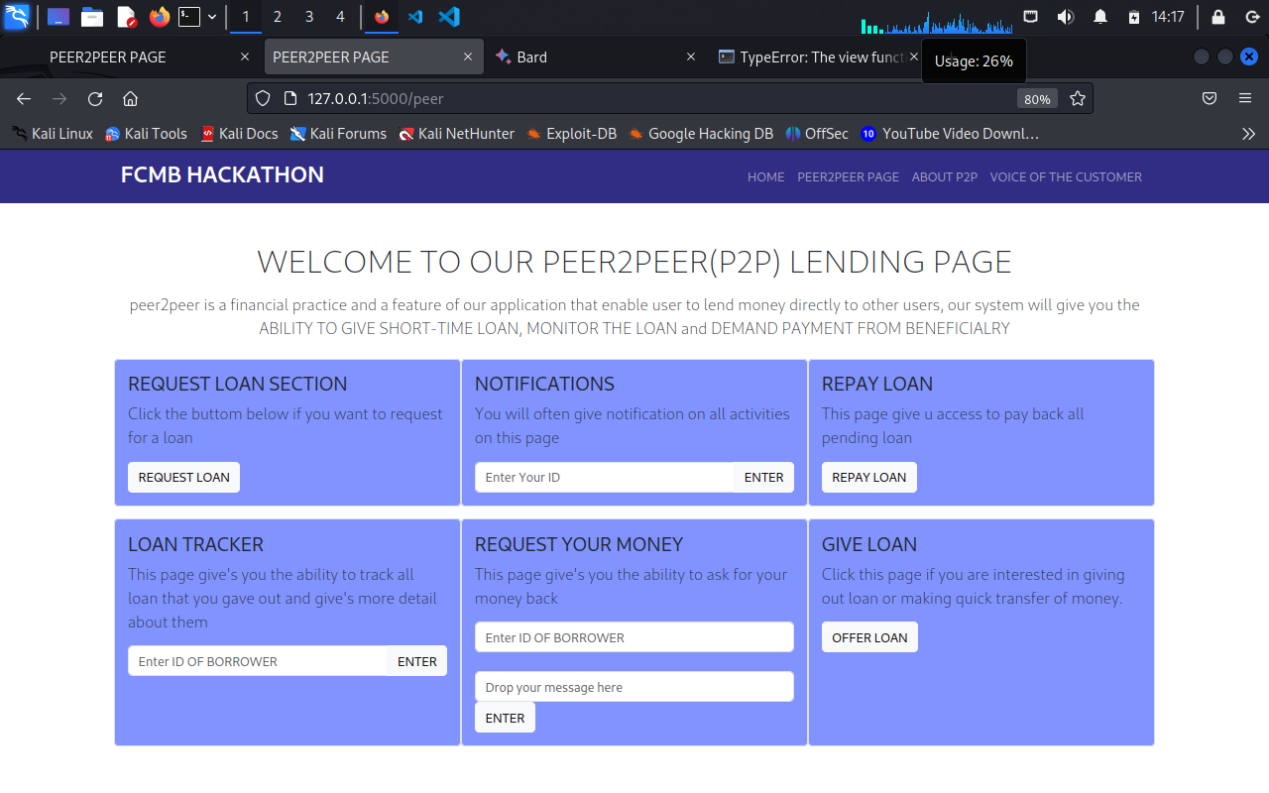

You can track your loan on in this section

Request loan section

Repay loan section

User will receive notification on this section

You can give a customer loan in this section

Request you loan back from lenders in this section

**REQUEST LOAN SECTION**

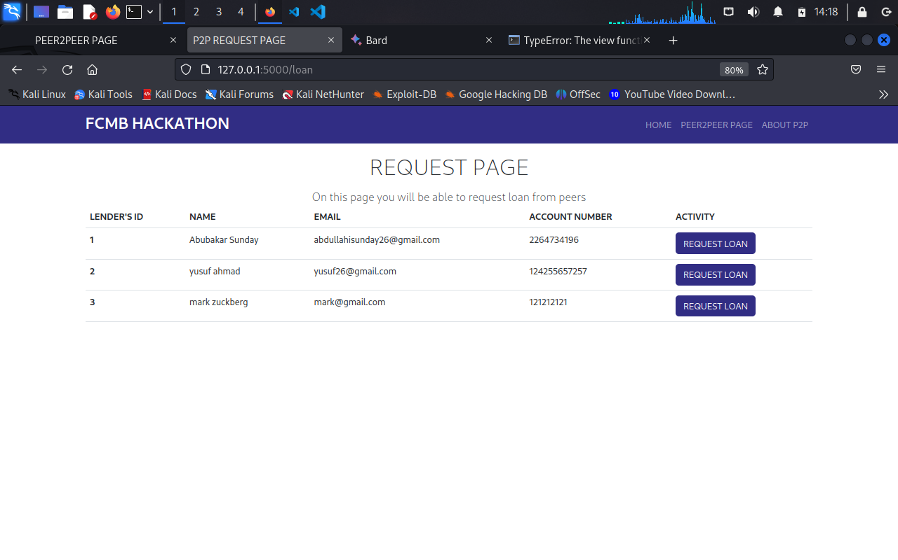

List of peers you can lend money from in the request loan section

**LOAN TRACKER SECTION**

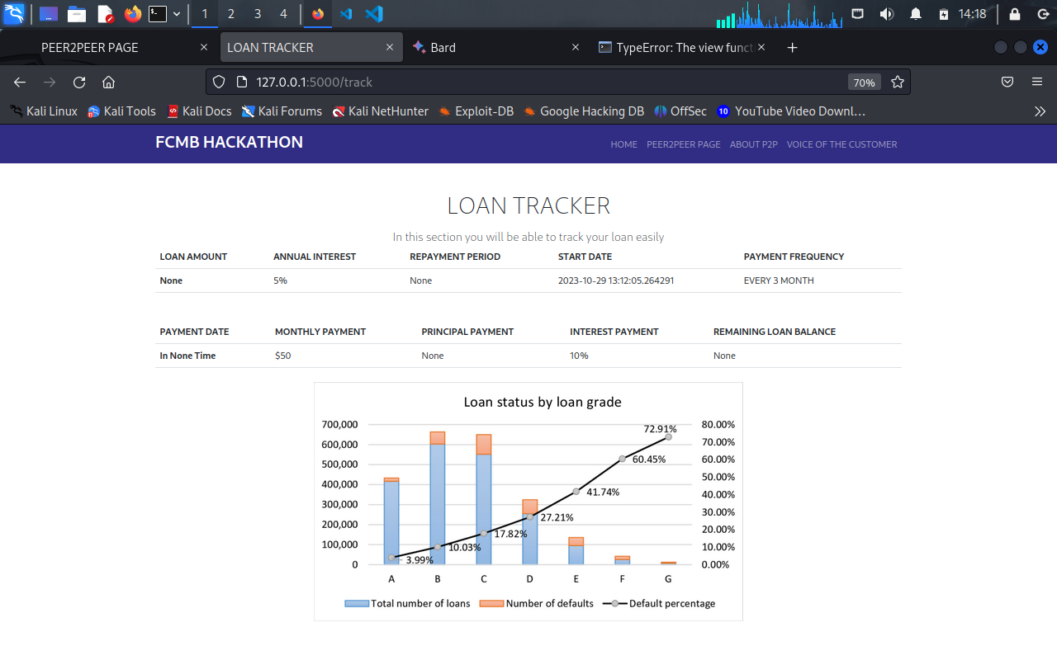

Frictional graph representation of the details

More details about loan, when to pay, interest rate and other detail

**ABOUT P2P**

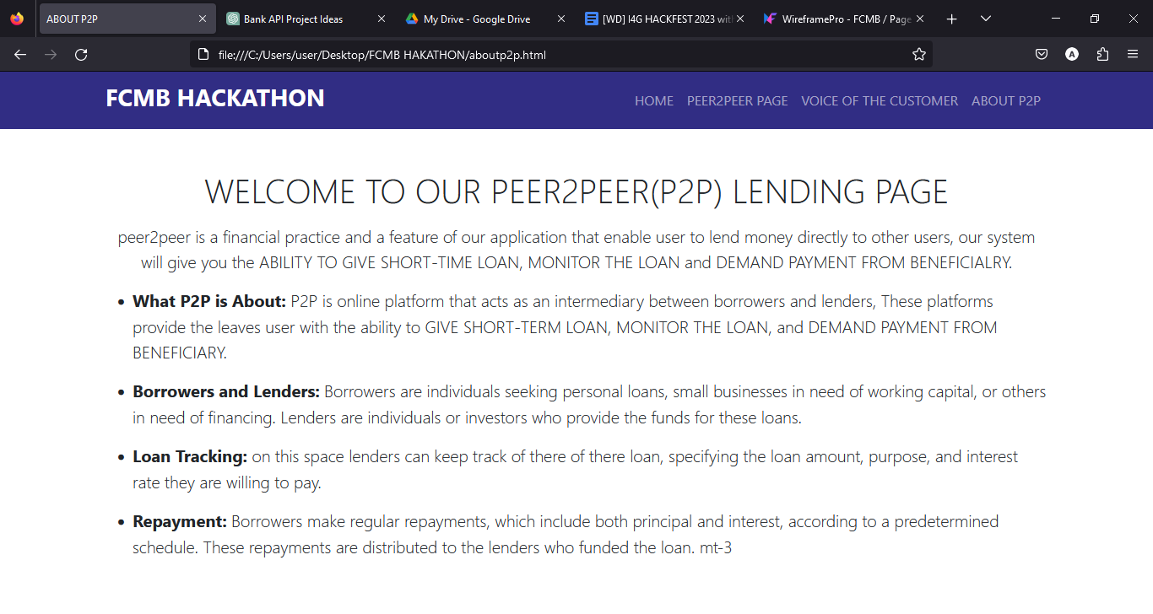

This page tell user more about peer2peer

**LOGI PAGE**

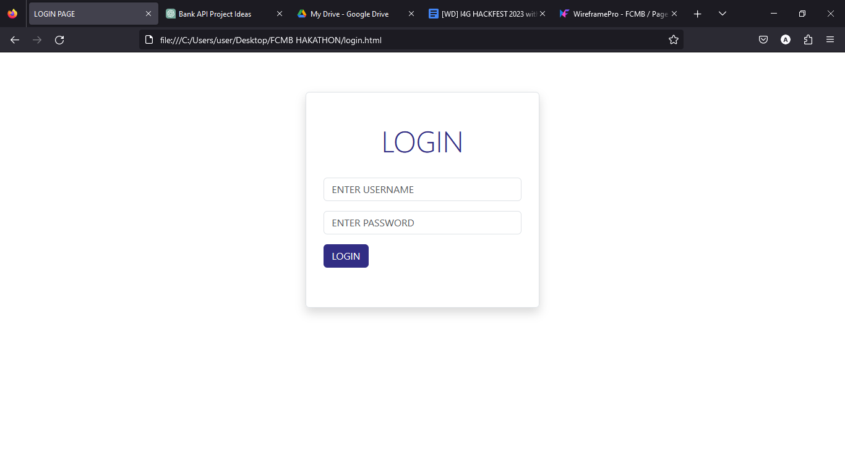

Enter password

Enter username

User can login to their account here